XXXorganisationxxx
Digital transformation strategy roadmap
Version X

Executive Summary
The executive summary should provide a high-level overview of the current digital technology environment and a summary of the key initiatives, timeframes, and costs.

Introduction

Organisation overview

Organisation strategy

Digital transformation strategy objectives
The digital transformation journey needs to spring from business strategy and organisational direction. Please highlight why you want to start digital transformation journey.

Authorisation
List here all persons that are signing the digital technology strategy roadmap document.

This document is authorized and agreed by the following key executives and stakeholders:
Name | Position
John Smith | CEO
Jane Smith | CIO
… | …

Process
Elaborate the process has been conducted to write this document. It can include staff survey, workshops, requirement gathering, digital capability quiz, process mapping, market research,

Current state - strengths and weaknesses
Summarise key findings from requirement gathering, workshops, staff survey, etc.

You can draw current digital technology ecosystem.

Identify your current technology strengths and also the weaknesses where you can improve your digital technology environment to help achieve your goals.

Domain | Strengths | Weaknesses
Client Case management | Intake process | Integration with other system  Access remotely to the system
Cyber security | Implemented basic password policy | Disaster recovery and business continuity
Digital marketing | Having adequate social media scheduling process | Social media strategy

Future state _ digital transformation roadmap
Now that you know the key challenges and gaps and you’ve identified the required courses of action, you can proceed. Go through the required actions and group the related ones together into packages of work. These are your initiatives, projects or programs. What you call them will be based on your own preferences, as well as the scope and complexity.

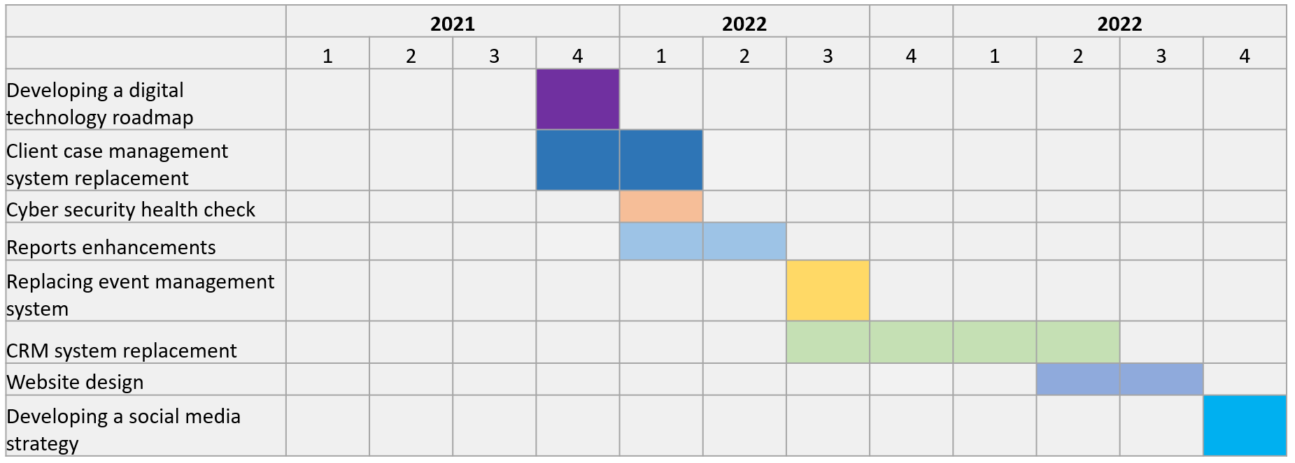
For each initiative, identify:
• the scope of the initiative (or what you intend to do; how will you know when you have finished?)
• when you intend to complete the initiative (this year, next year, etc), and how long it will take
• the benefit of undertaking the initiative – this can include things like more reliable systems, staff time savings, ability to work when out of the office, etc. You should be as specific as possible
• the resources required to complete the action (both funding and effort) – this is critical as when you have your plan approved, it is important that you are allocated the budget and/or time to undertake each identified action.

Appendices
Remember to keep your digital transformation strategy roadmap readable. Place supporting and extra information (such as network diagrams, PC asset lists, server configuration details, support information, etc) in appendices.

